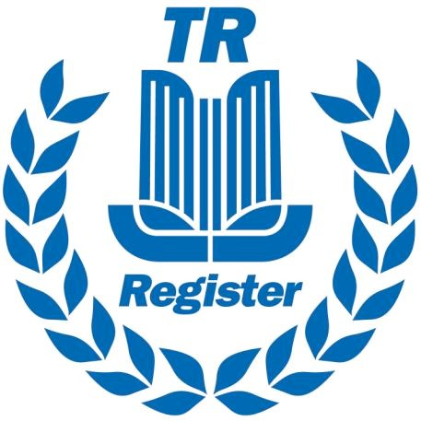
TR OWNERS CLUB LIMITED

Trading as TR Register

Nomination Form for Election or Co-option to the Management Team
Page 1 of 2.

NOMINEE

Name | __________________________ Membership number __________________
Directors Post | ______________________________________________________________
Address | ______________________________________________________________

________________________________________________________________________________

Business interests ______________________________________________________________

Motoring interests ______________________________________________________________

Signature __________________________ Date _______________________________

PROPOSED BY

Name __________________________ Membership number __________________

Address ______________________________________________________________

________________________________________________________________________________

Signature __________________________ Date _______________________________

SECONDED BY

Name __________________________ Membership number __________________

Address ______________________________________________________________

________________________________________________________________________________

Signature __________________________ Date _______________________________

Return this form to: TR Register, 1B Hawksworth, Southmead Industrial Park, Didcot, Oxfordshire. OX11 7HR. Alternatively, you may email: office@tr-register.co.uk
The form must be received at the above address by 23rd September 2020 at midnight.

Date received: |  |  |  |  |  |  |  |  |  | For office use only

TR OWNERS CLUB LIMITED

Trading as TR Register

Nomination Form for Election or Co-option to the Management Team
Page 2 of 2.

Please include a (300 word max.) personal statement detailing why you have the skills and experience required to meet the volunteer’s job description:

Date received: |  |  |  |  |  |  |  |  |  |  | For office use only

