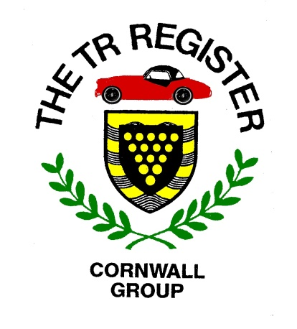

2020 Events List-v5
UPDATED 17/03/2020

PLEASE NOTE: Most of these events have already been cancelled, but you may wish to note the dates in the hope that some will take place later in the year.

The following is a draft list of events taking place in our region during 2020. In addition to our own Group events, we have included a number of others which are being laid on by other organisations who feel that TR Register members may be interested.
There should be something here to suit all tastes. If you aware of any other appropriate events or destinations, please let us know.
When confirmed details of Register group events are available, the following webpage will be updated, so keep looking in. You will see that the Register office now includes national events which may be of interest.
http://www.tr-register.co.uk/group/cornwall/events

April Sunday 5th – Afternoon Run to the Roseland peninsula with a visit to Miss V’s Tearoom at St. Just in Roseland. Meeting point will be announced.

April Saturday 11th – MCC Land’s End Trial. Spectate at Crackington, but the main focus will be on Blue Hills near St. Agnes. See the TRs in action on the Blue Hills cliff path, but also look out the cars which will be taking part in the second Land’s End Classic Road Trial and will be using the tarmac road from the bottom of the hill.

April Monday 13th – Kernow Old Vehicle Club Easter Road Run. Starting at 10:30 hrs. from The Smugglers Inn, St.Erth Praze TR27 6EG.

April Thursday 16th to April Tuesday 21st – Group visit to the Dorset area. Contact Pete Rugg before our March meeting if you are interested in coming along. NOW CANCELLED.

April Saturday 25th – Camborne Trevithick Day. Go to: www.trevithick-day.org.uk

April Sunday 26th – Drive it Day. Hoping for a little less rain this year, we will head West and a visit to Geevor Tin Mine. Details to follow.

May Sunday 3rd - Werrington Hillclimb near Launceston. More TRs taking part.

May Sunday 10th – Bude Classic Car Show.

May Sunday 17th – Afternoon Run. Possibly combined with the following.

May Sunday 17th – Boconnoc Country and Classics.

May Saturday 30th – Meeting with the Devon Group and TS2 at Buckfastleigh.
As part of the Register’s 50th Anniversary celebrations, TS2 will be spending some time in Cornwall and details will follow. The Devon Group have kindly invited Cornwall Group members to join them at their event.

June Tuesday 2nd – Evening Run.

July Tuesday 7th – Evening Run.

July Sunday 19th – Wheels at Wadebridge. Entry Forms are available on: www.wadebridgewheels.co.uk

July Saturday 25th & Sunday 26th – St. Buryan Rally TR19 6HP.

July Sunday 26th – Tregrehan Country and Classics.

August Tuesday 4th - Evening Run.

August 14th – 16th – WESES Rally at Stithians.

August 14th – 16th – Triumph Weekend at Stratford.

September Sunday 6th – A30 Retro Run.

September Sunday 13th – Afternoon Run.

September 11th - 13th TR Register Euromeet.
September Sunday 7th - Newquay Auto Club’s Classic & Sports Tour of Cornwall

October Sunday 4th – Club Triumph 27th RBRR
October Tuesday 6th – Winter Pub meeting.

November Tuesday 3rd - Winter Pub meeting.

December – Christmas Do. Details to follow.

ENJOY

