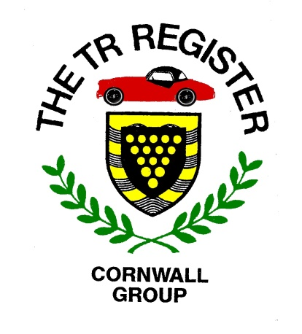

2020 Events List-v4-2
UPDATED 26/02/2020

The following is a draft list of events taking place in our region during 2020. In addition to our own Group events, we have included a number of others which are being laid on by other organisations who have kindly invited TR Register members to partake.
There should be something here to suit all tastes. If you aware of any other appropriate events or destinations, please let us know.
When confirmed details of Register group events are available, the following webpage will be updated, so keep looking in.
http://www.tr-register.co.uk/group/cornwall/events

March Tuesday 3rd – Winter Pub Magic Lantern Show meeting from around 20:00hrs. at The Victoria Inn, near Roche (PL26 8LQ) close to the Victoria Interchange on the A30. Once again there will be a random selection of images from history, ancient and modern. We will be using the conservatory. Arrive in good time to get the best seats in the house! We are hoping to offer a selection of homemade cake and sausage rolls in a bid to swell or numbers!

April Sunday 5th – Afternoon Run to the Roseland peninsula with a visit to Miss V’s Tearoom at St. Just in Roseland. Meeting point will be announced.

April Saturday 11th – MCC Land’s End Trial. Spectate at Crackington or Bluehills near St. Agnes. See the TRs in action.

April Thursday 16th to April Tuesday 21st – Group visit to the Dorset area. Contact Pete Rugg before our March meeting if you are interested in coming along.

April Sunday 26th – Drive it Day. Hoping for a little less rain this year, we will head West and a visit to Geevor Tin Mine. Details to follow.

May Sunday 3rd - Werrington Hillclimb near Launceston. More TRs taking part.

May Sunday 10th – Bude Classic Car Show.

May Sunday 17th – Afternoon Run. Possibly combined with the following.

May Sunday 17th – Boconnoc Country and Classics.

May Saturday 30th – Meeting with the Devon Group and TS2 at Buckfastleigh.
As part of the Register’s 50th Anniversary celebrations, TS2 will be spending some time in Cornwall and details will follow. The Devon Group have kindly invited Cornwall Group members to join them at their event.

June Tuesday 2nd – Evening Run.

July Tuesday 7th – Evening Run.

July Sunday 19th – Wheels at Wadebridge. Details to follow.

July Sunday 26th – Tregrehan Country and Classics.

August Tuesday 4th - Evening Run.

August 14th – 16th – WESES Rally at Stithians.

August 14th – 16th – Triumph Weekend at Stratford.

September Sunday 6th – A30 Retro Run.

September Sunday 13th – Afternoon Run.

September 11th - 13th TR Register Euromeet.

October Tuesday 6th – Winter Pub meeting.

November Tuesday 3rd - Winter Pub meeting.

December – Christmas Do. Details to follow.

ENJOY

