2020 Events List-v2
UPDATED 28/11/2019

The following is a draft list of events taking place in our region during 2020. In addition to our own Group events, we have included a number of others which are being laid on by other organisations who have kindly invited Cornish TR Register members to partake.
There should be something here to suit all tastes. If you aware of any other appropriate events or destinations, please let us know.
When confirmed details of Register group events are available, the following webpage will be updated, so keep looking in.
http://www.tr-register.co.uk/group/cornwall/events

January Saturday 4th – MCC Exeter Trial. Spectate at Tillerton, Fingle Bridge or Simms.

January Tuesday 7th - Winter Pub meeting from around 20:00hrs. at The Victoria Inn, near Roche (PL26 8LQ) close to the Victoria Interchange on the A30.

January Sunday 19th - Cape to Cape Scenic Tour.
For your first trip of 2020 in the TR, why not take part in this event?
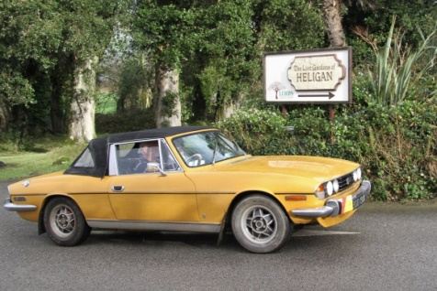
Details will appear shortly on our Events Page.

February Tuesday 4th – Winter Pub meeting from around 20:00hrs. at The Victoria Inn, near Roche (PL26 8LQ) close to the Victoria Interchange on the A30.

March Tuesday 3rd – Winter Pub meeting from around 20:00hrs. at The Victoria Inn, near Roche (PL26 8LQ) close to the Victoria Interchange on the A30.

April Saturday 11th – MCC Land’s End Trial. Spectate at Crackington or Bluehills near St. Agnes.

April Thursday 16th to April Tuesday 21st – Group visit to the Dorset area. Pete Rugg writes:
“I am liaising with the Dorset Group Leader Brian King so that we can link up with them.
I am proposing that we stay at Rockley Park Holiday Park located in Poole, BH15 4LZ. At present a 6 berth chalet for that period is about £400 depending on type.
We intend to visit Gurston Hillclimb near Salisbury on the Sunday as it is a round of the TR Register hill climb championship. Other visits potentially include the Bovington Tank Museum, Haynes Motor Museum and Sammy Millers Motorcycle museum.
If interested please let Peter Rugg know by the end of December.”

April Sunday 26th – Drive it Day. Details to follow.

July Sunday 19th – Wheels at Wadebridge. Date to be confirmed and details to follow.

September Sunday 6th – A30 Retro Run.
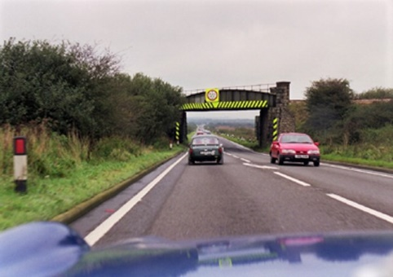
Is this warning early enough for you?
In 1999 and 2000 Pete Probst took it upon himself to organise the two runs from Launceston to Land’s End. Using as much of the A30 as remained and despite the poor weather, the events prove to be a great success.
Following a few years of discussion, Pete feels it is now time to revisit the event, especially as more of the old route seems to disappear each year.
Details will appear shortly on our Events Page.

