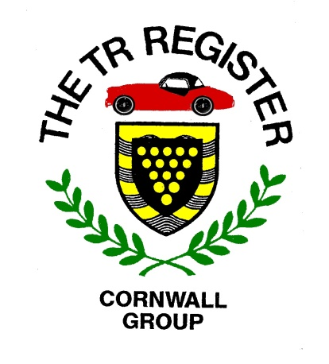
2019 Events List-v7
UPDATED 25/08/2019
Mother Nature has not been kind to us this year, but we hope that in the rest of 2019 she will treat us a little better.
The following is a draft list of events taking place in our region during the rest of this year. In addition to our own Group events, we have included a number of others which are being laid on by other organisations who have kindly invited Cornish TR Register members to partake.
There should be something here to suit all tastes. If you aware of any other appropriate events or destinations, please let us know.
When confirmed details of Register group events are available, the following webpage will be updated, so keep looking in.
http://www.tr-register.co.uk/group/cornwall/events

September 3rd – Evening Road Run to Bodmin Moor.

September 8th - Car & Bike Show at Truro High School for Girls in Falmouth Road, Truro (TR1 2HU). The school is organising this free to enter event as part of Motorsport Month in Cornwall. Any Group member wishing to take along their TR should contact Jon Dean for further details jdean@trurohigh.co.uk Pre-booking is strongly recommended.
https://docs.wixstatic.com/ugd/a1732e_c4045898260c4ecca5e7d0b3d22ab5af.pdf
..\Downloads\School - Aug.doc

September 29th – Newquay Auto Club have once again invited TR Register members to take part in their annual Classic & Sports Tour of Cornwall. Details can be found here:
https://www.tour.newquayautoclub.co.uk/
October 6th - Sunday afternoon run to the Roseland Peninsula.
November 6th – Winter Pub meeting.
November ?? - Charity Car Recognition Quiz at Mitchell.
December 3rd – Christmas Lunch.

As September 2019 is Motorsport Month in Cornwall, explore this site to see what is being organised: https://www.cornwallmotorsportmonth.com/
There is bound to be something there for everyone.

