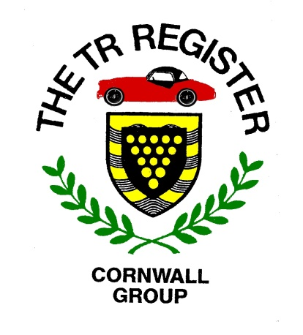
2019 Events List-v6
The following is a draft list of events taking place in our region during the rest of this year. In addition to our own Group events, we have included a number of others which are being laid on by other Register Groups and organisations who have kindly invited Cornish TR Register members to partake.
There should be something here to suit all tastes. If you aware of any other appropriate events or destinations, please let us know.
When confirmed details are available, the following webpage will be updated, so keep looking in.
http://www.tr-register.co.uk/group/cornwall/events

June 18th – Evening Road Run. CANCELLED.
June 23rd - The Great TR Breakfast Mega Meet @ Haynes International Motor Museum Sparkford. Anyone fancy a day trip out of the Duchy? For update of details, keep following and refreshing this link:
https://www.revingtontr.com/news/2019/mar/27/the-great-tr-breakfast-mega-meet-haynes-international
July 2nd – Evening Road Run. See Events Page.
July 14th – Wadebridge Wheels. Entry Form can be found here:
http://www.wadebridgewheels.co.uk/modules/wheelsregistration/register.aspx?id=20
July 20th - 21st – Sticker Heritage Rally.
July 21st – Tregrehan Classic Cars & Country Fayre. See Events Page for details.
August 6th – Evening Road Run.
August 10th – Carnhell Green Vintage Rally.
August 16th – 18th – TR Register/TSSC International Meeting at Stratford-upon-Avon.
August 16th – 18th - West of England Steam Engine Rally at Stithians.
September 3rd – Evening Road Run.
September 19th – Newquay Auto Club Classic & Sports Tour of Cornwall. Details will appear on our Events Page.
October 6th - Sunday afternoon run to the Roseland Peninsula.
November 6th – Winter Pub meeting.
November ?? - Charity Car Recognition Quiz at Mitchell.
December 3rd – Christmas Lunch.

