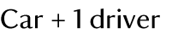

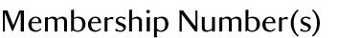

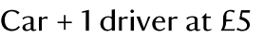

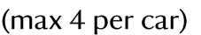

Sunday 13 May 2018

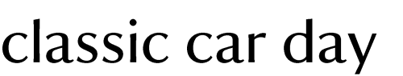

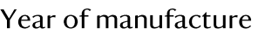

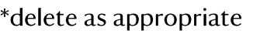

By returning this form you agree to the Terms and Conditions

Entry Terms & Conditions

- All cars to be in place on the show ground by 9.30am.
- All exhibitors are to display their car pass on the top left hand corner of their windscreens on arrival. This will enable the Marshalls to park you quickly and in your allocated parking place.
- All drivers and passengers to wear the wristbands provided. Failure to do so may result in you being asked to pay for entry.
- The owners and drivers of the exhibit must be covered by a current Third Party Insurance Policy, including exhibitor use. A copy of which MUST be made available for inspection by a National Trust official if requested.
- No exhibit may be left running unattended and if unattended MUST be left securely ‘braked and immobilized (ignition keys must be removed).
- Please note that due to Health & Safety regulations, you may not move your exhibiting vehicle or exit your designated area prior to 4.30pm on the day of the Rally. In exceptional circumstances a vehicle may be moved if under the control of a Marshall, this can be arranged from the Control Desk. At least half an hour will be required to organise this.
- The MAXIMUM speed limit of 5 MPH shall apply to all moving vehicles on the site. Any exhibitor found to be exceeding the speed limit will be asked to leave forthwith.
- Owners are responsible for their own personal effects.
- No discounts or refunds will be given due to adverse weather conditions which result in the show being abandoned.
- The closing date for club entries is the 24 April. All club entries received after this date will be entered as individuals. FINAL CLOSING DATE for individual entries is Friday 1 May unless the organisers deem it necessary to close the entry date early due to demand.

