TR Register
Lincolnshire Group
Annual General Meeting
18th January 2016
The Turnor Arms, Wragby.
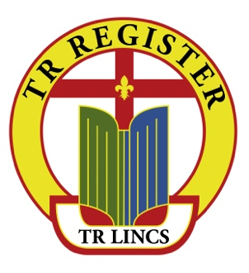
Agenda

- Appointment of Chair Adrian Lawton

- Apologies for Absence Allyson Pywell

- Minutes of 2015 AGM for approval Allyson Pywell

      - Matters arising: Adrian Lawton

      - Group Leader’s Report: Adrian Lawton

      - Treasurer’s Report: Malcolm Brown

      - Election/Re-election of Officers: Chairman

        - Group Leader
        - Secretary
        - Treasurer
        - Spares Secretary
        - Competition Secretary

      - 2016 Activities Calendar Group Leader
      - AOB Group Leader

      - Date and venue for 2017 AGM Secretary

