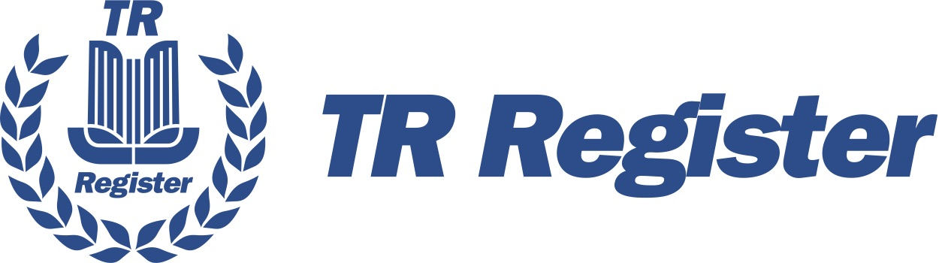

Using our membership portal

To access the membership portal to manage your membership, go to www.tr-register.co.uk, and login to your account using the members icon in the top right corner.

Login using your email address and password. From the members dashboard, click on Member Admin to access the membership portal.
If you are already logged in, go to the members dashboard option under the membership menu, or

The portal page
There is a menu at the top of the page (as seen on a PC)
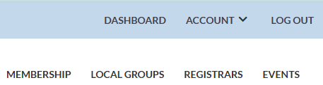
If you are using a phone or a tablet is will look like this
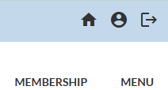
The page will have option items further down, but for the moment we will concentrate on the menu.

Menu Options
or takes you to your membership section
or gives you options to go to the Profile section, the Payments section, and the Privacy Section.
will show you menu options for Membership, Local Groups, Registrars and Events.

Sections in the portal
The main portal screen is seen when you first login. The welcome screen looks like
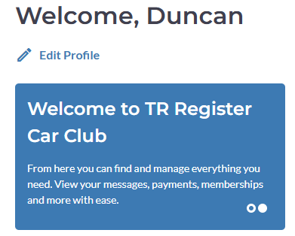
If you scroll down you will see Current Memberships
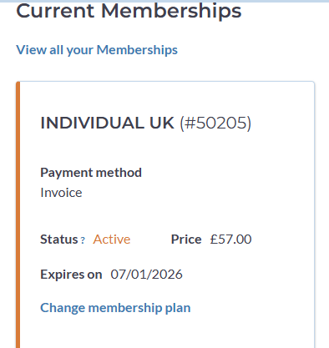
And following that, Your Teams. These are our Local Groups and it is here you can see which group you are currently in, and where you can join another group if you wish. See the section called Teams / Groups later on.
Scrolling down further, you will get to the Events section, which will show you any local group events you have signed up to , or any national events that you are attending. See the section called Events later on.
The next section down is where you can manage your vehicles. See the section on vehicles later on.
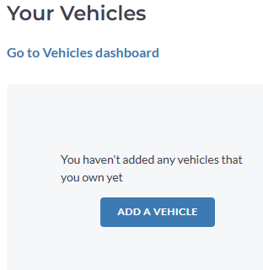

The last section we are using is Recent Payments
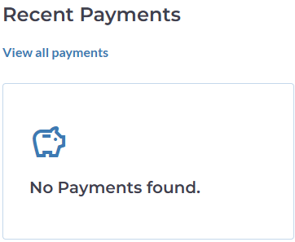
Your Applications
We do not use this section. If there is anything in there, please ignore it at this time.

Managing your profile
This is where you can keep your address and phone details. Complete the changes you wish and scroll to the bottom of the page to find the Save Changes button.
You cannot change your email address here, so you will need to send an email to office@tr-register.co.uk with you old and new email addresses for them to be changed.

Changing your password
From the welcome page, scroll down to the bottom of the screen, where you will find a link to change your password. It looks like this
Clicking this will send you a security code by email, which you can enter, after which you can type in a new password.

Managing your Membership
In this section you will find details on your membership, its status, and when it renews.
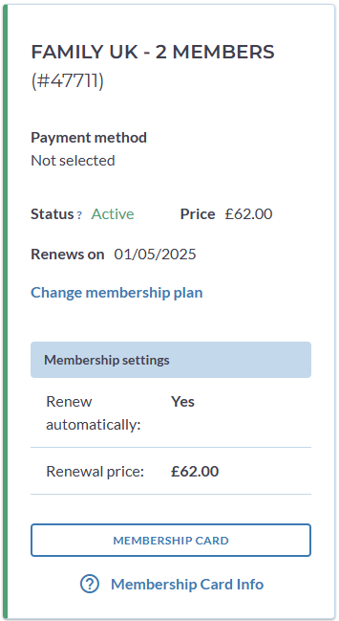

Adding additional family members
If your membership plan is a Family one, then you can add your family members to your membership by clicking on the View all your Memberships link. This will show your membership as above again, but then below that is a Your Members section.
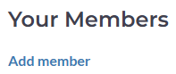
Click on the Add member to add a new family member. If you see this screen
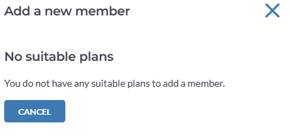
Then you have reached your limit of family members, or you do not have a family membership plan. If you have a family member, you will see their details, and you can manage their profile with the Manage member link. This will allow you to change the name & email address for the family member.
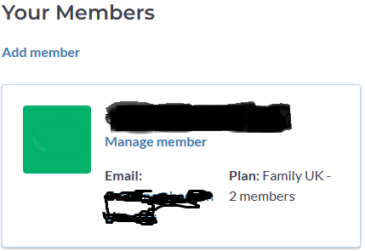
While you are in Manage member, you can option to remove the family member completely by using the REMOVE MEMBER link.

Family Members
Family members who have their own email addresses, and you have entered that email address, can manage their own profile by registering on that portal using the email address. This will connect them to their account, and allow them to put in profile information, and join a group in their own right.
Changing your membership type
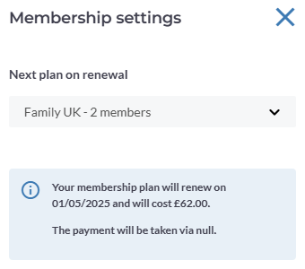
You can change your membership plan from next renewal. Click on the Change membership plan link, and select the membership plan you wish to go to.

Membership cards
If you want to get your membership card, click on the 
button and choose Print Membership card from the menu. On a phone, this will download a PDF document which you can print out.
Click on the for more help.

Teams or Groups
In the membership portal, local groups are currently called Teams, but this should change on the future.
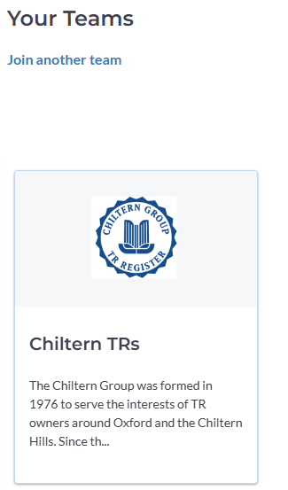
Clicking on the group will take you to the group pages. After the about section, if you scroll down you will see a News section, and below that Upcoming events where you can see the events the group are running in the future.

Joining another group
You are able to join more than one group if you wish. Click on the Join another team link, and select the group you wish to join. Scroll through the introduction section to find the join link
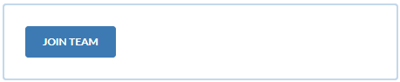

Events
The Upcoming events section will show you any events that you have booked.
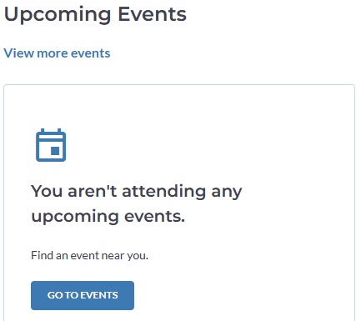

To find an event, click on the View more events link or the Go To Events button.

Upcoming Events
From here, you can search for events.
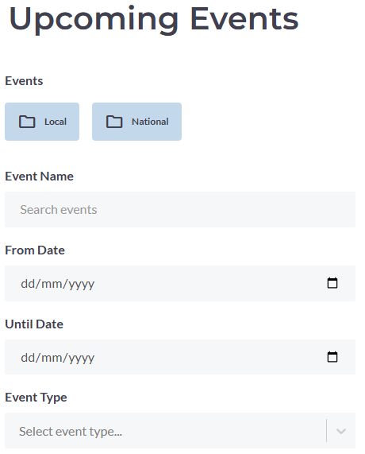

If you know the name or date, complete the relevant fields and the events list will be displayed below.
If you know it is a local group event click on the Local button 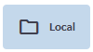, or for National events only, click on 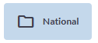. If there are any categories of events for your selections, new buttons may appear which allow you to further select. 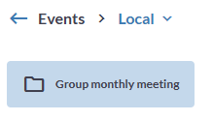When you see the event you are interested in, click on it.

If there is a Tickets button 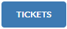 click on it to book tickets. Tickets may be free and are then used to count the number of attendees, or may be a cost option, in which case you can choose the number of tickets and pay for them within the portal.

Vehicles
In this section you can manage the cars you own. Click on the Go to Vehicles dashboard link to open.
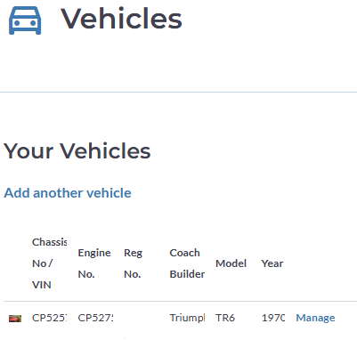

Add a vehicle
To add a vehicle, click on the Add a vehicle or Add another vehicle link. Fill in the chassis number, engine number and registration. Ass you type in these fields, the system will search our existing vehicle register and will display any matches it finds below.
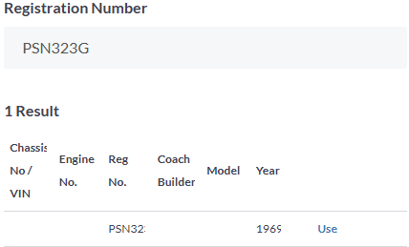
Here it found a match, and to use the details click on the Use link. If there is no match, then you can add the details manually using the Manually add Vehicle details link just below. Add as much detail as you know to the vehicle input screen that is presented. Click on the save button when you have finished your changes which is located at the bottom of the screen.

Manage an existing vehicle
In the vehicle list there is a manage link. 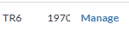Click on that to show the details from where you can edit the details as you see fit. Click on the save button when you have finished your changes which is located at the bottom of the screen.
In the top right corner you will see this 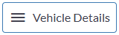Click on it to get further options that you can enter.
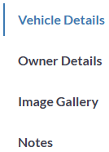
Make sure you click on the save button between making changes in different sections.

Owner details
Here you can enter the details about your ownership of the vehicle.

Image gallery
Here you can upload any pictures that you would like to keep with the vehicle – such as competitions, restorations, show etc.

Notes
Add any notes you want to keep about the vehicle. Tell us what work you have done of the vehicle for example, or anything of note that would be of interest to future owners.
