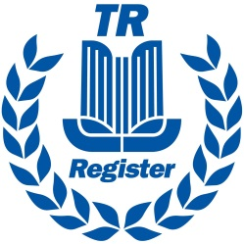 | Derbyshire Dales Group

Derbyshire Dales TR Group AGM 14th February 2018
Agenda

- Nominate and agree a minute taker.
- To receive and record apologies for absence.
- Approve minutes of the 2017 AGM as a true record.
- Treasurers report
- Approve the 2017 Accounts.
- Election of officers.
Firstly:-
All officers are prepared to stand for re-election and as there have been no other nominations for any of the posts I suggest that the committee be re-elected on mass.
Proposer
Seconder
- Group leaders report.
- AOB

