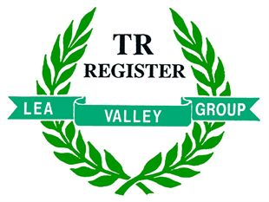
The Lea Valley Group Autumn Expedition to The Isle of Wight
Friday 15 September to Monday 18 September
We are planning an all-inclusive weekend away on the Isle of Wight, staying at the Warner Leisure Hotel at Bembridge and participating in the Classic Car Extravaganza on the Ryde Esplanade on the Sunday. This car show is extremely popular, with participants not only from all over the UK but also from mainland Europe. It is held to support two charities, with donations being given to charity representatives attending the events. The Saturday charity is Round Table and the Sunday charity is the Earl Mountbatten Hospice based at Cowes.
The trip involves driving down to Portsmouth to take a late afternoon ferry to the mainland and arrive at the hotel on Friday. Saturday is planned to be a ‘day at leisure’, when you can relax at the hotel, stroll along the beach, tour the island or go along to Newport and have a look at a few hundred classic cars. On Sunday, we plan to drive to Ryde and park in the display area on the Esplanade to show our cars to the world. The return to the mainland on Monday will be on a late afternoon ferry from Fishbourne.
The Warner Hotel package is for a double/twin room, breakfast and three course evening meals and entertainment. We currently have 10 rooms on standby for our group. This enables us to offer the weekend package at £540, covering hotel room and meals, return car ferry and a £4/car levy to pay for the council and police costs of administering road closures.
To enable us to take advantage of these rates, we need to confirm bookings to Warners by MONDAY 24 APRIL. More rooms may be available but may attract a higher cost.
To make your reservation for this BIG-4 LVG expedition, please complete the form below and return it to Pierre Miles together with a deposit of £100 (ferry ticket + room deposit) before Monday 24 April 2017.
Note that the balance of the cost (£440) must be paid before Friday 30 June 2017.
Cheques to be made payable to ‘TRR Lea Valley Group’.

- - - - - - - - - - - - - - - - - - - - - - - - - - - - - - - - - - - - - - - - - - - - - - - - - - - - - - - - - - - - - - - - - - - - - - - - - - - - - - - - - -

Lea Valley Group Expedition to the Isle of Wight: 15-18 September 2017

Please register me for participation in this event.
I enclose payment of £100 as a deposit and agree to pay the £440 balance of the charge before Friday 30 June.
Registration number of vehicle: _________________ (Required for printing of
Driver name: ________________________________ vehicle pass to the show area)

Print name: ________________________________ Signature: ______________________________

